CS 396 Project 3 Report

Yichun Zhou

In this project, I did an APP for a restaurant which allow users to view the menu, put down the quantity for food in order to order foods. Display what the user ordered, allow user to enter tips amount or use seek bar to set the percentage for tips, allow enable the split bills feature. At the end, display a message box for user including all order information as a receipt.

I used Android Studio to implement the project, it is based on Java programming language, and the APP will be shown using an Android mobile phone or the emulator built in the Android Studio.

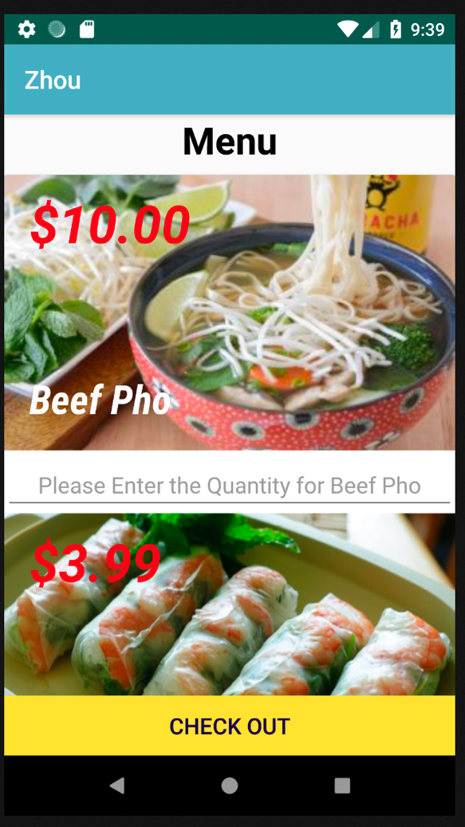The APP I built has two major pages. One is the main page which is the menu page, currently has four images of food, with several layout and Textview on top that display the price and the food name. Below each image, there are EditText boxes which allow user to input the numbers which would be the quantity of the food they want to order. Please view *fig. 1* below.

*fig. 1*

The quantity of each food will be passed to the second page, which is the order information page. Please view *fig. 2* below. There are mainly three sections in this page. On the top of the page, there is the order summary section, that display the quantity of each food and prices of all the food combined. Next section includes tips and total price. The EditText box in this section allows user to enter numbers as the tip amount, or user could use the seek bar below to choose the percentage for the tip. After user enter tip amount or drag the seek bar, the total price will be calculated by food price plus the tips, please view *fig. 3.*

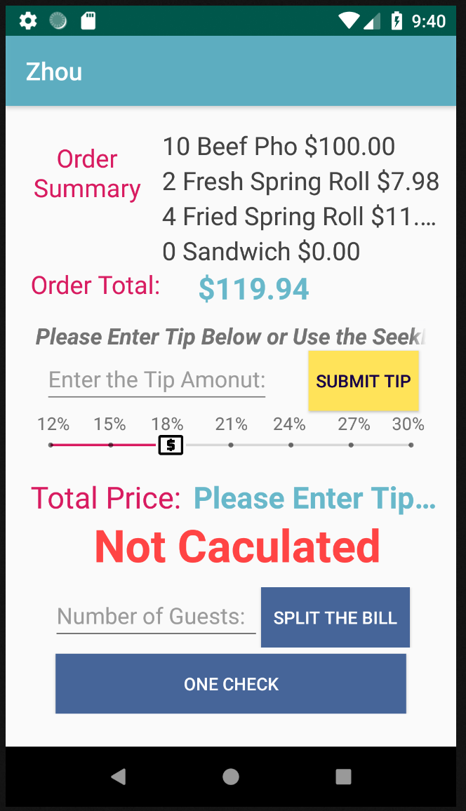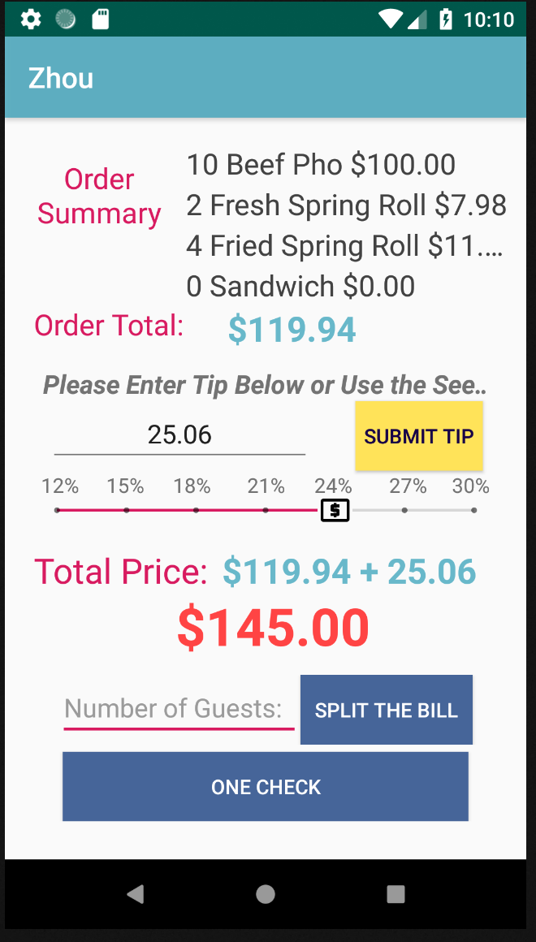

*fig. 2 fig. 3*

The third section of this page would be the split bills section, that allow user to enter the guests number in the EditText box, and after click the split the bill button, a message box will pop-up and display all order information, such as food they ordered, the price for food, the tips and the bill amount for each customer. Please view *fig. 4.* Also, user could choose not split the bill by clicking the one check button, order information will show up with the total price without splitting the bill. Please view *fig. 5*.

*fig. 4 fig. 5*

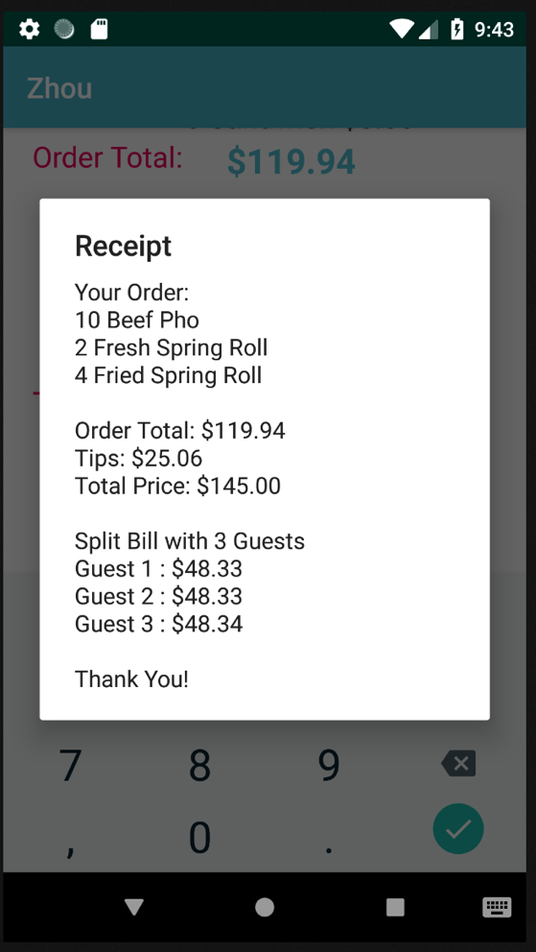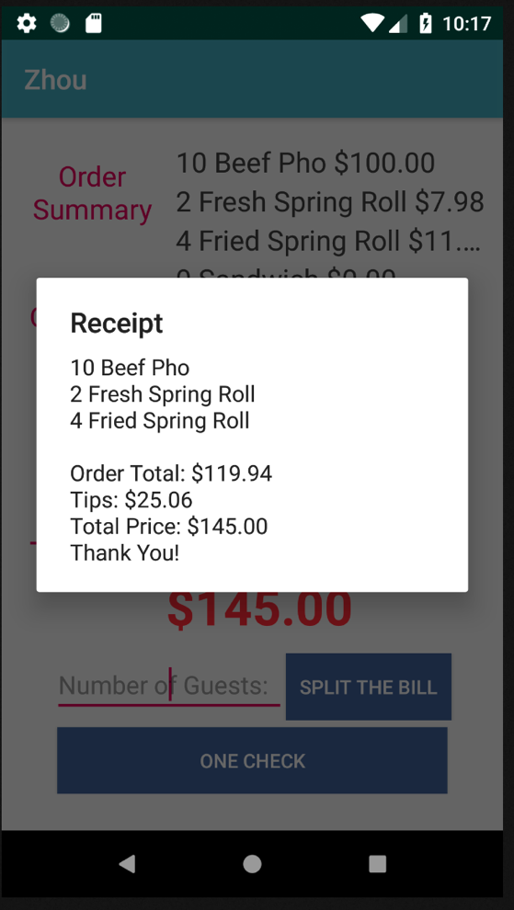

**Known Problems, Bugs, Limitations, Unimplemented Features**

If the guest number is huge, the lost penny problem sometimes would not be solved.

According to one of my friends who tested the APP, he said the tip amount section might caused confusing. User sometime does not know whether they use the seek bar or not.

**References**

<https://www.bilibili.com/video/av18008899/?p=1>

<https://developer.android.com/reference/android/support/v7/widget/CardView>

<https://developer.android.com/studio/intro/>